Creating a react project
Step 1
Create a new folder somewhere for your projects
Step 2
Open the folder in visual studio code
Step 3
Make sure you have the terminal open. If not, at the top you have the button for terminal -> New Terminal
Step 4
In the terminal, run the command

npm create vite@latest my-app
- It will ask you to select a framework. Choose “React”
- It will ask you to select a template. Choose “JavaScript”

Step 5
The project folder will be created inside the active directory you ran the command from.
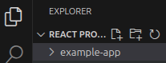
In the terminal, you should see this. This means the dev server is now working. You can hold the ctrl key and left click on the blue link to open your website. Alternatively you can go to this address in your browser.
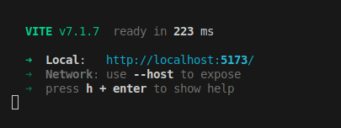

IMPORTANT NOTE ON RESTARTING THE SERVER
If you ever are restarting the server, you need to make sure your terminal active path is your project folder.
Example:
Wrong
Correct

To navigate in the terminal, you can use the cd command
Cd name-of-your-project-folder-here
OR
Go to file -> open folder and select the newly created folder

Then to start the server, in the terminal run
Npm run dev
Example:

Step 6
Open the website
Either ctrl + left click on the localhost link in the terminal, or in the browser go to http://localhost:5173/

The website will look like this:
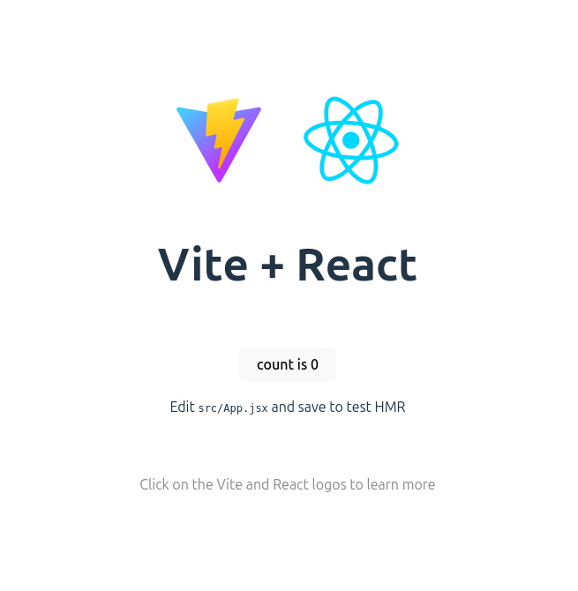

Step 8
In your project folder, navigate to src -> App.jsx
This is where your code starts.
Optionally you can also change the website metadata in the head element of the index.html file

Step 9
You can remove the example code. Change app.jsx to look like this

App.jsx
import './App.css'
function App() {
return (
<>
<header>
some header
</header>
<main id="main-content">
main content here
</main>
<footer>
some footer
</footer>
</>
)
}
export default App

Step 10
You can also remove unused css
Go to app.css and remove everything since its just styling for the example code
Then in index.css we will remove most of the code, and add a little bit to it.

App.css
Remove everything

Replace the index.css with this. We remove the css that comes with the template, we remove default margins, and we add setup for our page layout.
Index.css
:root {
font-family: system-ui, Avenir, Helvetica, Arial, sans-serif;
line-height: 1.5;
font-weight: 400;

/* we remove the default colors from here, Keeping the font optimisations*/
font-synthesis: none;
text-rendering: optimizeLegibility;
-webkit-font-smoothing: antialiased;
-moz-osx-font-smoothing: grayscale;
}

/* --ADD THE BELOW */
/* remove the default margin */
*, *::before, *::after {
margin: 0;
box-sizing: border-box;
}

/* set up the app to take the vieport size */
#root{
display: flex;
flex-direction: column;
min-height: 100vh;
width: 100%;
}

/* make the content grow to push footer down */
#main-content{
flex: 1;
}

Explanation * selector:
*, *:::before, *::after - This will select EVERYTHING. Every single element on every single page.

Margin:0 - A lot of html tags come with default margins. Personally, I don’t like them. I find that it causes a lot of unexpected behaviour with elements not ending up where you expected them to be.

This will remove all default margins, we will add our own as needed.

Since we often end up working from figma designs, the default margins are pretty much never what we need anyway, so we have to set them manually.

Explanation #root
The element with the id of root is where all of our app will actually be located. If we inspect our page we can see it.
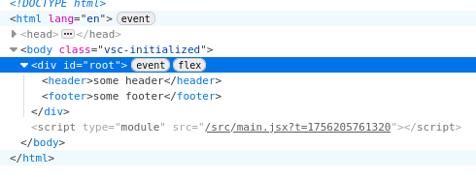
By using flexbox and making this element always take at least the height of the page, it will be easy to make sure the footer is always at the bottom

Explanation flex:1 :
Flex: 1, will make the element grow itself to take the max of the remaining available space. Because main-content is nested inside the root element, and we set the root in the earlier step to always be at least screen height, main will grow until the footer touches the bottom.

Final notes
There are hundreds of ways to do all of this, this is just one method. The css setup will work well for any website design that follows the basic layout of having a header at the top, footer at the bottom, and content in the middle. More complex designs might require adjustment.

